**Lab-8**

**Hirenbhai Shah ID: 27**

**Dinesh Paduru ID : 19**

**Q1 and Q3**

We have merged this two question as I am taking output of 1st question and displaying it as a notification on smartwatch. We have done twitter streaming for doing sentiment analysis by using **StanfordcoreNLP** library. We have filter out tweets as per current presidential election to decide the sentiment of the user. As its rate on scale of 1 to 5 for negative to positive, in output I am showing tweets along with its category as a notification to the smart device. Below are the snap shots for it:

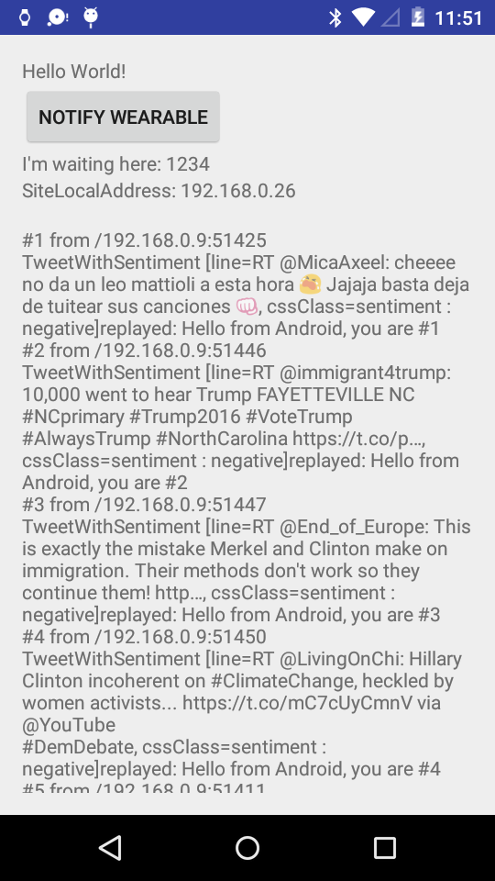

**SmartWear notification :**

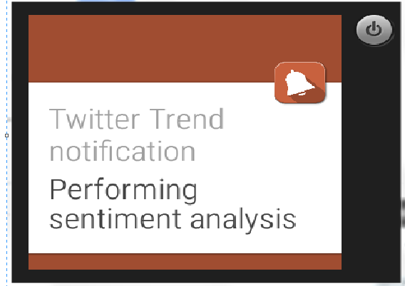

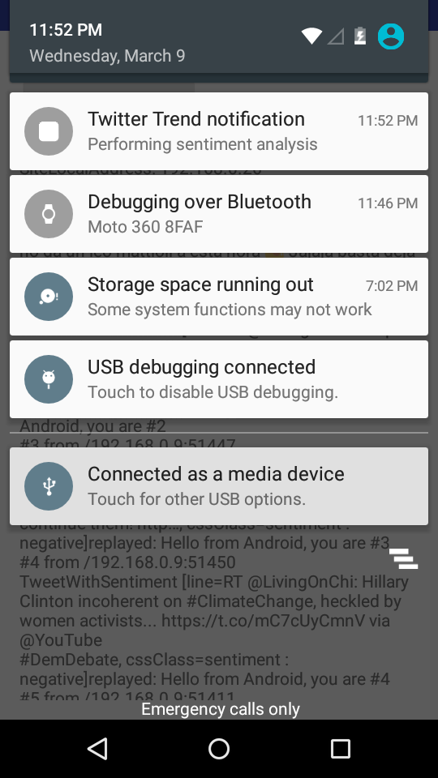

**Q2 and Q4**

We are trying to make recommendation system to recommend user some important tweets on basis of some famous medical hashtags. We have predefined our filter hashtags and filtering tweets in streaming. Below is the filter file.



For now we have divided it into below mentioned 4 categories. These categories are on basis of hashtags:

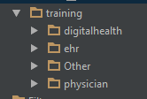

We are training the data for this 4 categories and will test them against the future tweets. For now its just 4 categories but we will include more and plan is to ask user for his interest of tweet and on basis of that we will find appropriate tweet. The selection criteria for choosing tweet from streaming will be on basis of ratings. Program will decide ratings on basis of user’s input and how influenced that tweet is to others people so far. We will include sentiment analysis as well for making sure that positive tweets will reach to user.

Below is the sample predicted results for few tweets.



Above three files are the collected tweets during streaming and below is the predicted output:

Now we will prepare schema for userid,category and also for collected tweets, which we are storing for prediction. The scema will be userid,tweet,category,rating.

We recommend 3-4 times a day tweets to the user as a notification to smart device.